TRC FRENCH RAID June 2018
TRC member are you interested in a day out riding in Northern France staring at Calais riding along the coast to Wimal then inland for a lunch stop in Ardres then back to the Calais port along the canal.
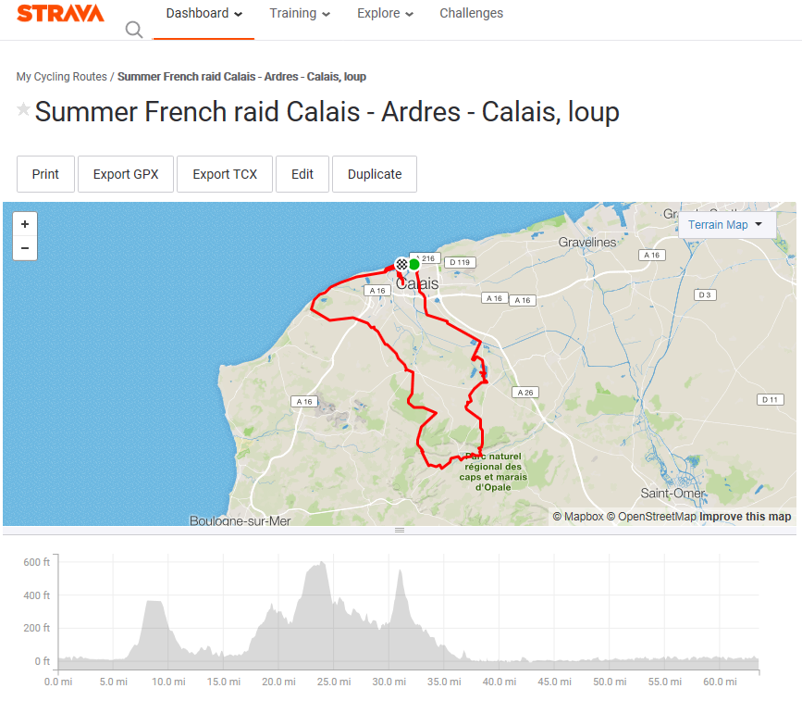
Proposed date …….June 16th Arrive Dover for outward bound ferry.. 7am ish
Route to follow is on Strava so can be downloaded. See above.
Restaurant .. Le Freigate Ardres ( beside the lake)
Return to Calais for return ferry…………5-6pm All times stated are local times.
Cost:
Lunch as much or as little as you like to pay.
Ferry depending on mode of transport rider numbers by cars/vans or by bike. To review once number booked in.
If successful could become an annual French raid.

Please let me know by facebook message
Email to sissons349@btinternet.com
Need to know by end April to finalise arrangements.

